Week 4 Dashboard Testing Report
Purpose
The purpose of dashboard testing was to verify that all visualizations, KPI cards, and calculations displayed accurate information from the source dataset. Testing was performed using SQL query outputs and dashboard results.
Test Cases
Test Case ID | Component | Expected Result | Actual Result | Status
TC01 | Total Registrations KPI | 650 | 650 | Pass
TC02 | Total Attendance KPI | 499 | 499 | Pass
TC03 | Attendance Rate KPI | 76.77% | 76.77% | Pass
TC04 | Total Volunteers KPI | 20 | 20 | Pass
TC05 | Total Incidents KPI | 40 | 40 | Pass
TC06 | Avg Resolution Time KPI | 34.3 min | 34.3 min | Pass
TC07 | Registration Analysis Page | Chart loads correctly | Passed | Pass
TC08 | Attendance Analysis Page | Pie chart displays correctly | Passed | Pass
TC09 | Volunteer Analysis Page | Task distribution visible | Passed | Pass
TC10 | Incident Analysis Page | Incident charts visible | Passed | Pass

Testing Summary
A total of 10 test cases were executed. All test cases passed successfully. KPI values displayed in the dashboard matched the values calculated directly from the SQLite database. No major defects were identified during testing.

Screenshots
- Executive Summary page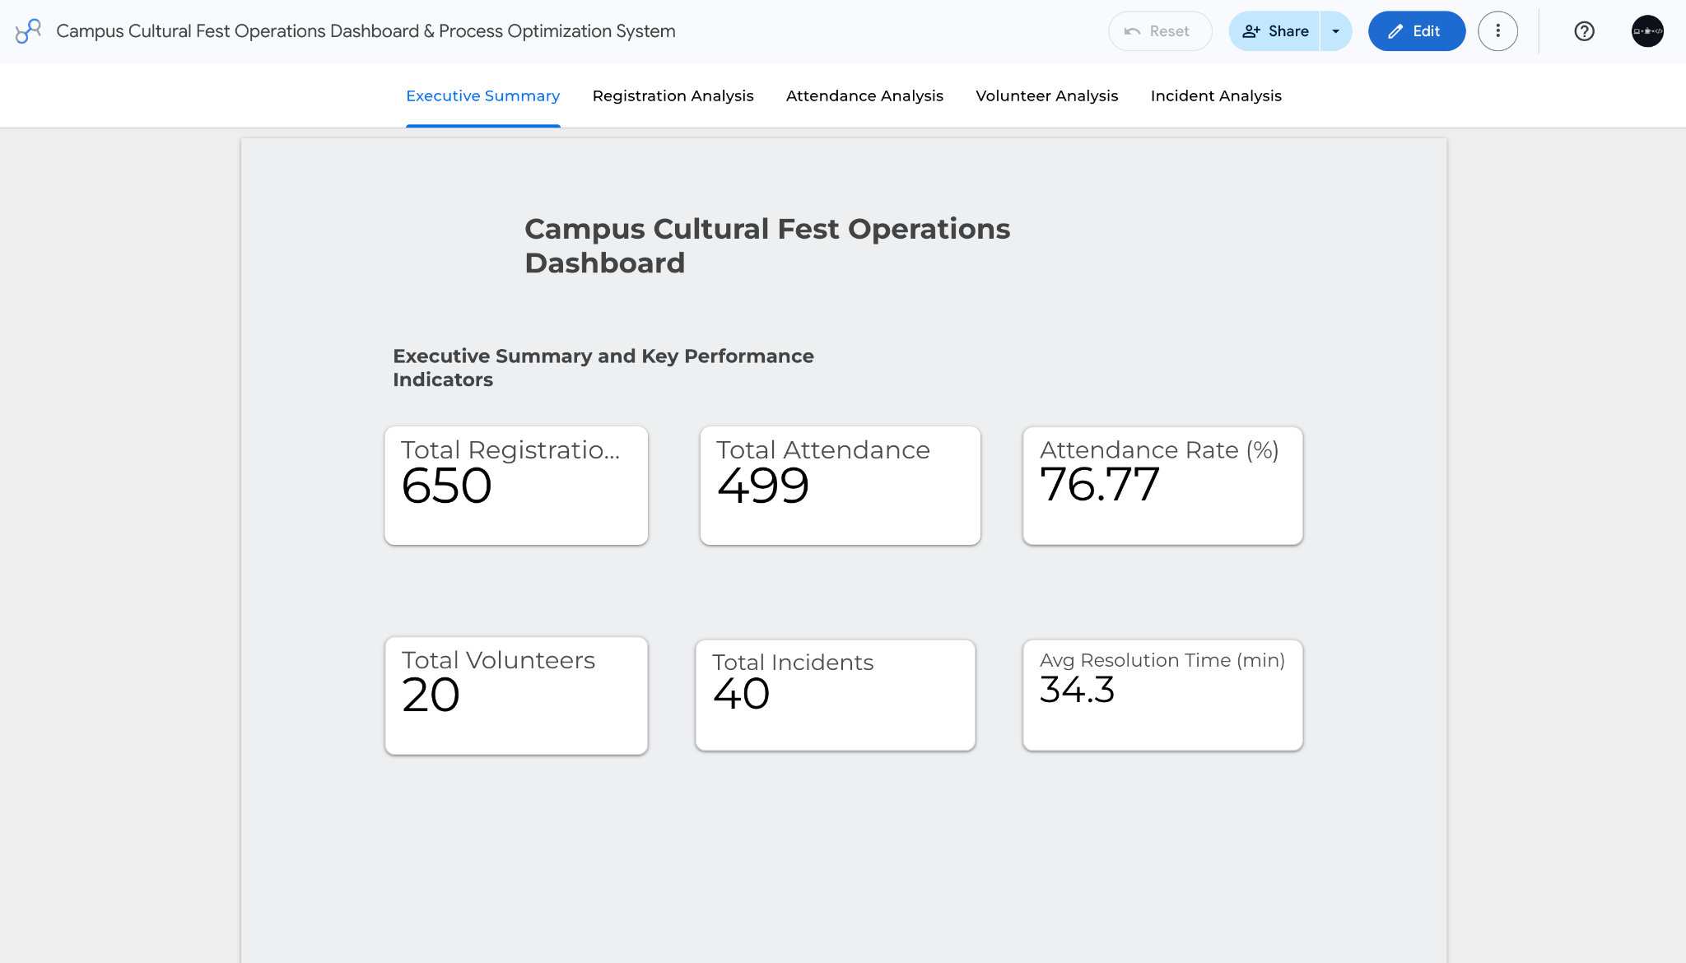

- Registration Analysis page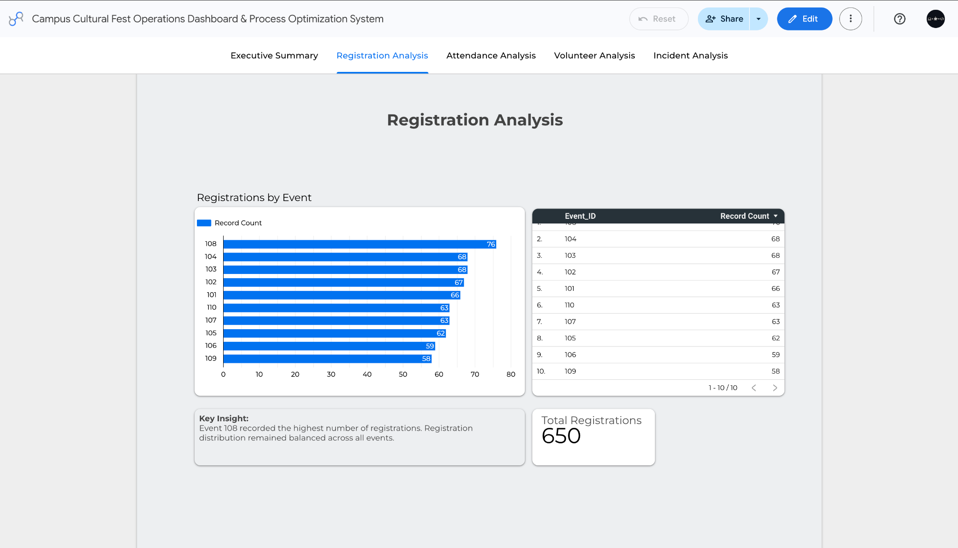
- Attendance Analysis page
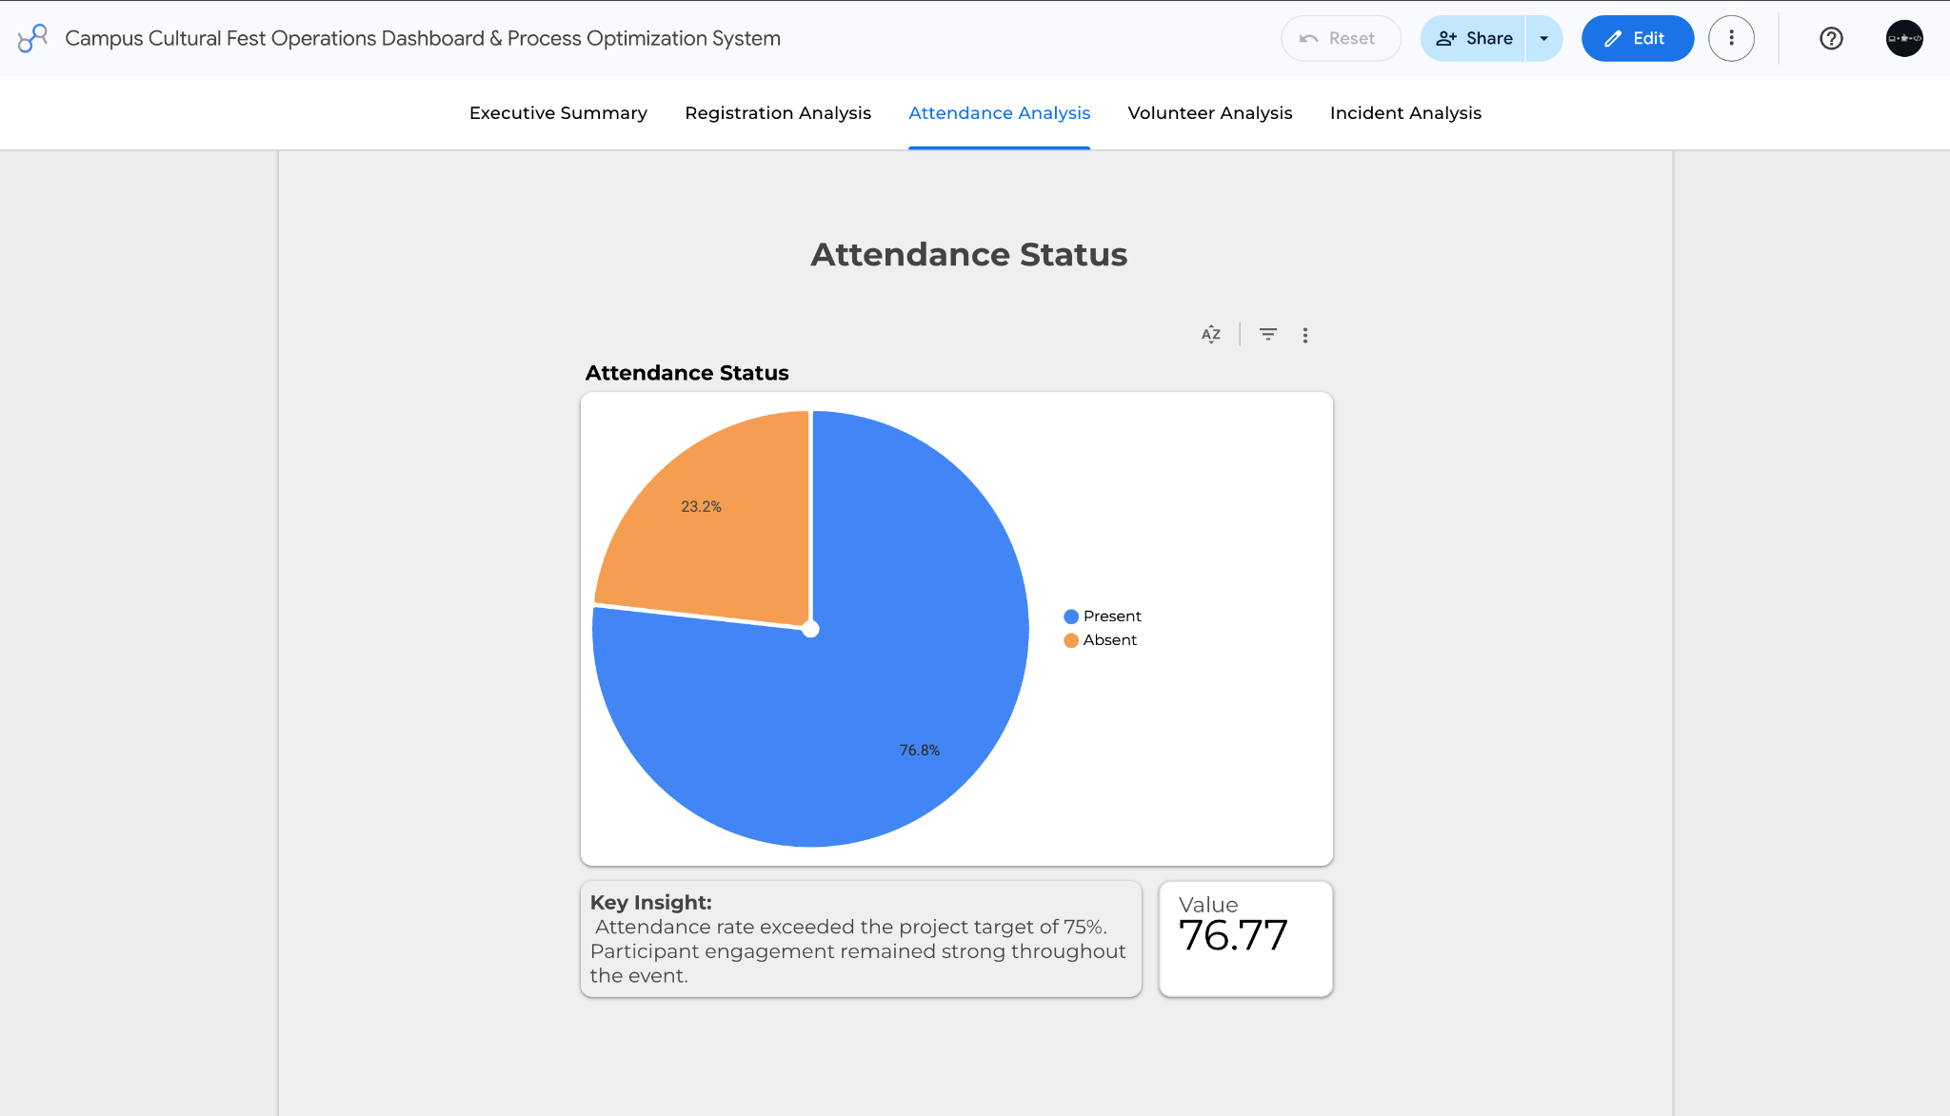

- Volunteer Analysis page
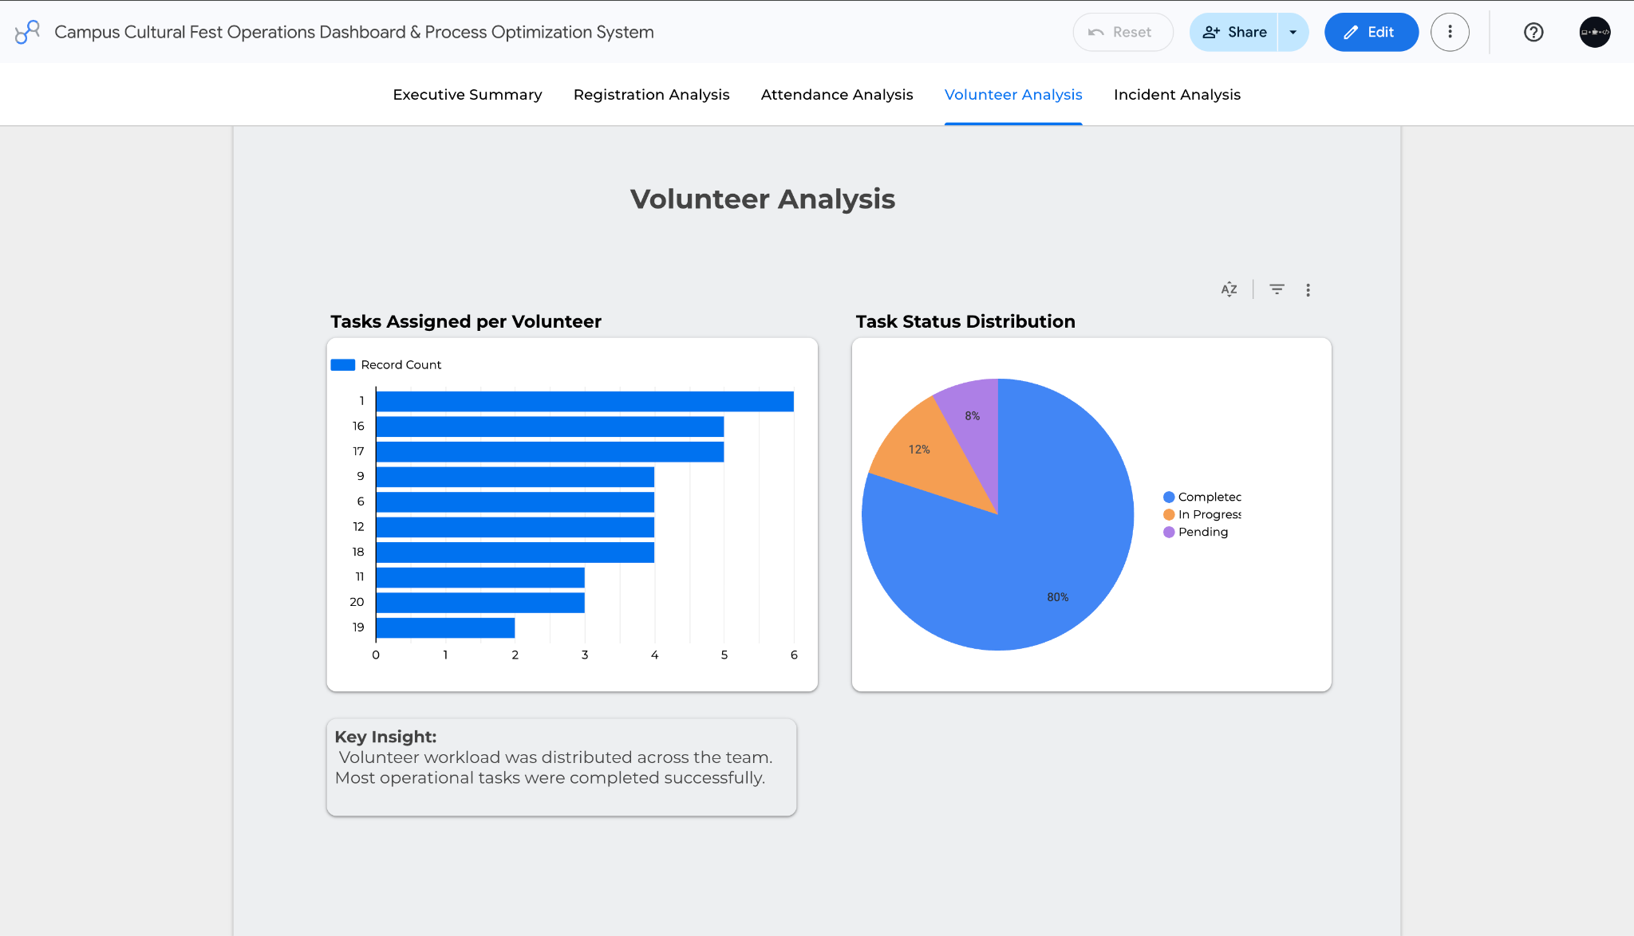

- Incident Analysis page
